**Durand Sportsmen’s Association**

**General Meeting**

**November 11, 2024**

Meeting was called to order by Tina Holmes at 7:00 p.m.

Meeting was opened by the whole assembly standing and quoting the Pledge of Allegiance.

**Roll Call of Officers:** Present were Tina Holmes, Scott McLavy, Aileen Kukulis, Brett Johnson, Derrick Alward, Ryan Sworthwood, Ryan Kruger, Joe Perri, Kristi Wagner Scott McClavy, and Martin Perez

**Absent:** Chuck Detweiller and Martin Perez

**Motion:** By Ryan Kruger and seconded Larry Holmes to approve the meeting minutes from October 2024. All yeas motion carries.

Financials: Money was moved over to order clay targets, added two new departments -clubhouse and clubhouse renovations.

**Motion:** By Brett Johnson seconded by Aileen Kukulis to approve financials. All yeas motion carries.

**Additional Reports/Department Reports:**

1. **Clubhouse:** Kristy: minimum wage increase is on February to 12.50
   * **Motion:** By Joe Perri to increase Trap help to $11 in January and 12.50 in February to meet state guidelines.
   * Closing will follow school closures, announced on the website and through email
2. **Pond:** all set
3. **Clubhouse Rentals/Ground use**: Trap team using it December 06/07 for the glow walk

**D: Grounds Maintenance**: Chase: not present

**E: Trap/Skeet:** Brett: target order delivered and put away

1. **Outdoor ranges**: None at the current time
2. **Archery**: No update
3. **Education Update**: No events took place, nothing currently on the books.
4. **Projects Update**: No update

**New Business:**

1. Christmas family has 5 kids, Tags are on the tree for anyone looking to help out.
2. Raffle update: Several tickets have been sold, will continue to advertise tickets.

-Just over 400 sold

1. Buck Pole: No questions, 3 adults, 2 kids so far.

**Old Business**:

1. Chuck Brought up dissolution of the club at the beginning of the meeting, Re stated that the club is not dissolving, but the 4-h declined information required by the state for DSA to put them as the beneficiary in case the club ever does have to dissolve. Beneficiary was changed to a non-profit, due to the fact that the 4-h had to be removed without the correct information. Any Questions or comments were asked to be brought to the next board meeting, 11/11/2024, no one was present with questions or concerns.
2. Winter Trap League: Can we reach out to other clubs for participation?
3. Looking into solar panels for the lights, Brett/Joe to get a new quote

**Adjournment:** Ryan Kruger motion to adjourn, seconded by Tina Holmes, meeting adjourned at 9:00pm.

Respectfully Submitted,

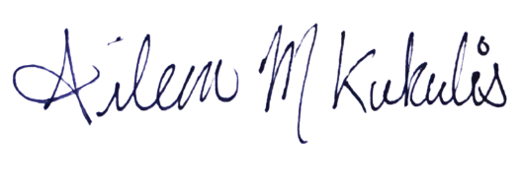

Aileen Kukulis

Secretary