**Durand Sportsmen’s Association**

**General Meeting**

**April 21, 2025**

Meeting was called to order by Tina Holmes at 7:00 p.m.

Meeting was opened by the whole assembly standing and quoting the Pledge of Allegiance.

**Roll Call of Officers:** Present were Tina Holmes, Scott McLavy, Aileen Kukulis, Derrick Alward, Ryan Kruger, Joe Perri, Kristi Wagner, Ryan Sworthwood, Larry Holmes III and Martin Perez and Chuck Detweiller

**Absent:** Brett Johnson

**Motion:** By Ryan Kruger and seconded by Derrick Alward to approve the meeting minutes from March 22, 2025. All yeas motion carries.

Financials:

1. Joe stated he still has to get the CD closed out, will attempt this week
2. One outstanding check still for the raffle winners.

**Motion:** By Ryan S seconded by Kristi to approve financials. Roll Call, All yeas motion carries.

**Additional Reports/Department Reports:**

1. **Clubhouse:** All set
2. **Pond:** all set
3. **Clubhouse Rentals/Ground use**: All set, add rentals to the website

**D: Grounds Maintenance**: All Set

**E: Trap/Skeet:** Brett: Absent

1. **Outdoor ranges**: None at the current time
2. **Archery**: No update
3. **Education Update**: No events took place, nothing currently on the books.
4. **Projects Update**: No update

**New Business:**

1. Five stand discussion
   1. Tina submitted information for a grant for up to $30,000.
   2. Howell has some up for sale
   3. Looking for sponsorships
   4. Look into rounding up a sponsorship form for local businesses.
2. Discussion about the clays in the woods and creating a clay station, blended together to be able utilize the targets on the trail instead of them going to waste.
3. Molded ear plugs-Tuesday and Wednesday of Next week, 04/29 and 04/30. Signups are on facebook, the website and the trap teams band app.

**Adjournment:** Ryan Sworthwood motion to adjourn, seconded by Tina Holmes, meeting adjourned at 8:34pm.

Respectfully Submitted,

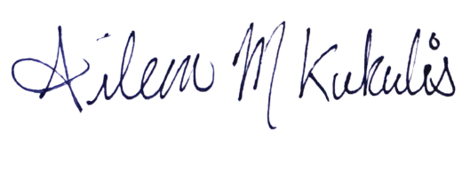

Aileen Kukulis

Secretary